**IMPLEMENTATION DETAILS:**

Lorem ipsum lorem ipsum Lorem ipsum lorem ipsum Lorem ipsum lorem ipsum Lorem ipsum lorem ipsum

**TEST CASE 1:**

In section *Anexes* you can find screenshots of the paths found by each algorithm.

|  |  |  |  |  |  |
| --- | --- | --- | --- | --- | --- |
|  | TRADIOTIONAL A* (NO TIE BREAKING) | TRADIOTIONAL A* (WITH TIE BREAKING) | | NODE ARRAY A* | A* WITH GOAL BOUNDING |
| Fill | 16% | 13% | 16% | | 14% |
| Nodes visited | 847 | 708 | 848 | | 751 |
| Nodes processed | 752 | 608 | 757 | | 686 |
| Max open list size | 97 | 104 | 97 | | 77 |
| Total processing time | 1.146s | 0.838s | 1.097s | | 1.001s |
| Processing time per node | 0.0015s | 0.0013s | 0.0014s | | 0.0015s |
| GetBestAndRemove | 15 calls | 15 calls | 756 calls | | 667 calls |
| AddToOpen | 35 calls | 15 calls | 847 calls | | 749 calls |
| SearchInOpen | 109 calls | 102 calls | 0 calls | | 0 calls |
| RemoveFromOpen | 15 calls | 15 calls | 756 calls | | 667 calls |
| Replace | 3 calls | 1 call | 0 calls | | 0 calls |
| AddToClosed | 15 calls | 15 calls | 756 calls | | 667 calls |
| SearchInClosed | 109 calls | 102 calls | 0 calls | | 0 calls |
| RemoveFromClosed | 0 calls | 0 calls | 0 calls | | 0 calls |

**TEST CASE 2:**

|  |  |  |  |  |  |
| --- | --- | --- | --- | --- | --- |
|  | TRADIOTIONAL A* (NO TIE BREAKING) | TRADIOTIONAL A* (WITH TIE BREAKING) | | NODE ARRAY A* | A* WITH GOAL BOUNDING |
| Fill | 12% | 10% | 12% | | 9% |
| Nodes visited | 640 | 523 | 641 | | 481 |
| Nodes processed | 553 | 436 | 568 | | 445 |
| Max open list size | 89 | 91 | 88 | | 52 |
| Total processing time | 0.813s | 0.607s | 0.830s | | 0.659s |
| Processing time per node | 0.0015s | 0.0014s | 0.0015s | | 0.0015s |
| GetBestAndRemove | 15 calls | 15 calls | 561 calls | | 441 calls |
| AddToOpen | 16 calls | 16 calls | 634 calls | | 480 calls |
| SearchInOpen | 111 calls | 110 calls | 0 calls | | 0 calls |
| RemoveFromOpen | 15 calls | 15 calls | 561 calls | | 441 calls |
| Replace | 8 calls | 10 calls | 0 calls | | 0 calls |
| AddToClosed | 15 calls | 15 calls | 561 calls | | 441 calls |
| SearchInClosed | 111 calls | 110 calls | 0 calls | | 0 calls |
| RemoveFromClosed | 0 calls | 0 calls | 0 calls | |  |

**TEST CASE 3:**

|  |  |  |  |  |  |
| --- | --- | --- | --- | --- | --- |
|  | TRADIOTIONAL A* (NO TIE BREAKING) | TRADIOTIONAL A* (WITH TIE BREAKING) | | NODE ARRAY A* | A* WITH GOAL BOUNDING |
| Fill | 17% | 14% | 17% | | 13% |
| Nodes visited | 898 | 734 | 899 | | 717 |
| Nodes processed | 815 | 644 | 820 | | 674 |
| Max open list size | 88 | 92 | 89 | | 84 |
| Total processing time | 1.212s | 0.902s | 1.220s | | 0.982s |
| Processing time per node | 0.0015s | 0.0014s | 0.0015s | | 0.0015s |
| GetBestAndRemove | 15 calls | 15 calls | 819 calls | | 672 calls |
| AddToOpen | 13 calls | 14 calls | 895 calls | | 717 calls |
| SearchInOpen | 108 calls | 116 calls | 0 calls | | 0 calls |
| RemoveFromOpen | 15 calls | 15 calls | 819 calls | | 672 calls |
| Replace | 7 calls | 14 calls | 0 calls | | 0 calls |
| AddToClosed | 15 calls | 15 calls | 819 calls | | 672 calls |
| SearchInClosed | 108 calls | 116 calls | 0 calls | | 0 calls |
| RemoveFromClosed | 0 calls | 0 calls | 0 calls | | 0 calls |

**TEST CASE 4:**

|  |  |  |  |  |  |
| --- | --- | --- | --- | --- | --- |
|  | TRADIOTIONAL A* (NO TIE BREAKING) | TRADIOTIONAL A* (WITH TIE BREAKING) | | NODE ARRAY A* | A* WITH GOAL BOUNDING |
| Fill | 26% | 20% | 26% | | 12% |
| Nodes visited | 1365 | 1080 | 1366 | | 622 |
| Nodes processed | 1226 | 905 | 1235 | | 560 |
| Max open list size | 156 | 177 | 156 | | 72 |
| Total processing time | 1.855s | 1.301s | 1.815s | | 0.825s |
| Processing time per node | 0.0015s | 0.0014s | 0.0015s | | 0.0015s |
| GetBestAndRemove | 15 calls | 15 calls | 1233 calls | | 559 calls |
| AddToOpen | 19 calls | 27 calls | 1366 calls | | 622 calls |
| SearchInOpen | 110 calls | 119 calls | 0 calls | | 0 calls |
| RemoveFromOpen | 15 calls | 15 calls | 1233 calls | | 559 calls |
| Replace | 2 calls | 9 calls | 0 calls | | 0 calls |
| AddToClosed | 15 calls | 15 calls | 1233 calls | | 559 calls |
| SearchInClosed | 110 calls | 119 calls | 0 calls | | 0 calls |
| RemoveFromClosed | 0 calls | 0 calls | 0 calls | | 0 calls |

**TEST CASE 5:**

|  |  |  |  |  |  |
| --- | --- | --- | --- | --- | --- |
|  | TRADIOTIONAL A* (NO TIE BREAKING) | TRADIOTIONAL A* (WITH TIE BREAKING) | | NODE ARRAY A* | A* WITH GOAL BOUNDING |
| Fill | 25% | 17% | 25% | | 22% |
| Nodes visited | 1357 | 899 | 1358 | | 1191 |
| Nodes processed | 1187 | 768 | 1199 | | 1055 |
| Max open list size | 172 | 133 | 169 | | 144 |
| Total processing time | 1.818 | 1.169s | 1.739s | | 1.573s |
| Processing time per node | 0.0015s | 0.0015s | 0.0015s | | 0.0015s |
| GetBestAndRemove | 15 calls | 15 calls | 1195 calls | | 1040 calls |
| AddToOpen | 13 calls | 14 calls | 1357 calls | | 1186 calls |
| SearchInOpen | 103 calls | 97 calls | 0 calls | | 0 calls |
| RemoveFromOpen | 15 calls | 15 calls | 1195 calls | | 1040 calls |
| Replace | 4 calls | 2 calls | 0 calls | | 0 calls |
| AddToClosed | 15 calls | 15 calls | 1195 calls | | 1040 calls |
| SearchInClosed | 103 calls | 97 calls | 0 calls | | 0 calls |
| RemoveFromClosed | 0 calls | 0 calls | 0 calls | | 0 calls |

**TEST CASE 6:**

|  |  |  |  |  |  |
| --- | --- | --- | --- | --- | --- |
|  | TRADIOTIONAL A* (NO TIE BREAKING) | TRADIOTIONAL A* (WITH TIE BREAKING) | | NODE ARRAY A* | A* WITH GOAL BOUNDING |
| Fill | 45% | 37% | 45% | | 38% |
| Nodes visited | 2382 | 1981 | 2383 | | 2057 |
| Nodes processed | 2231 | 1801 | 2242 | | 1943 |
| Max open list size | 156 | 182 | 157 | | 130 |
| Total processing time | 3.285 | 2.758 | 2.961s | | 2.548s |
| Processing time per node | 0.0015s | 0.0015s | 0.0013s | | 0.0013s |
| GetBestAndRemove | 15 calls | 15 calls | 2233 calls | | 1939 calls |
| AddToOpen | 14 calls | 15 calls | 2380 calls | | 2057 calls |
| SearchInOpen | 110 calls | 107 calls | 0 calls | | 0 calls |
| RemoveFromOpen | 15 calls | 15 calls | 2233 calls | | 1939 calls |
| Replace | 6 calls | 9 calls | 0 calls | | 0 calls |
| AddToClosed | 15 calls | 15 calls | 2233 calls | | 1939 calls |
| SearchInClosed | 110 calls | 107 calls | 0 calls | | 0 calls |
| RemoveFromClosed | 0 calls | 0 calls | 0 calls | | 0 calls |

**ALGORITHM ANALYSIS AND COMPARISON:**

Lorem ipsum lorem ipsum Lorem ipsum lorem ipsum Lorem ipsum lorem ipsum Lorem ipsum lorem ipsum

Lorem ipsum lorem ipsum Lorem ipsum lorem ipsum Lorem ipsum lorem ipsum Lorem ipsum lorem ipsum

**ANEXES:**

Figure 1 - Test case 1 for A*, no tie breaker

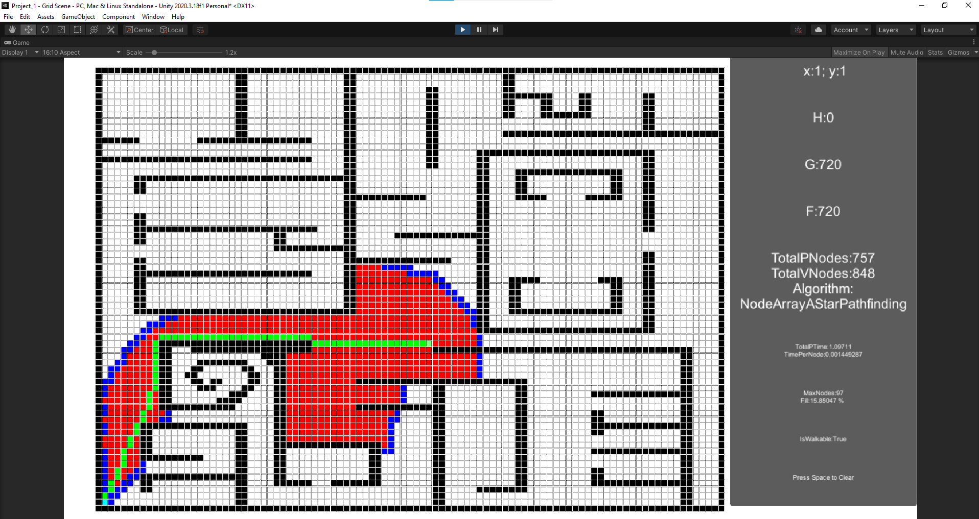

Figure - Test case 1 for Node Array A*

Figure - Test case 1 for Goal Bound

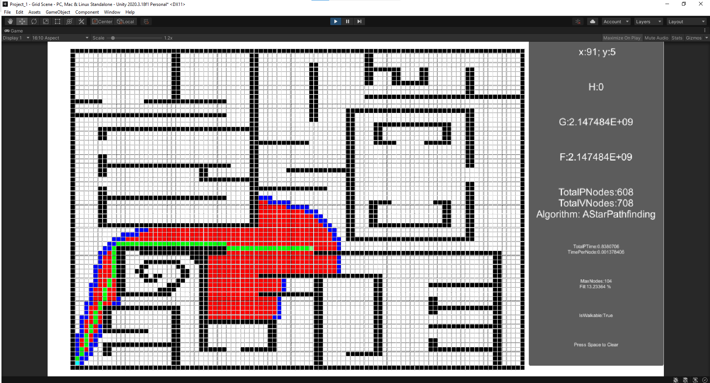

Figure - Test case 1 for A* with tie breaker

Figure - Test case 2 for A*, no tie breaker

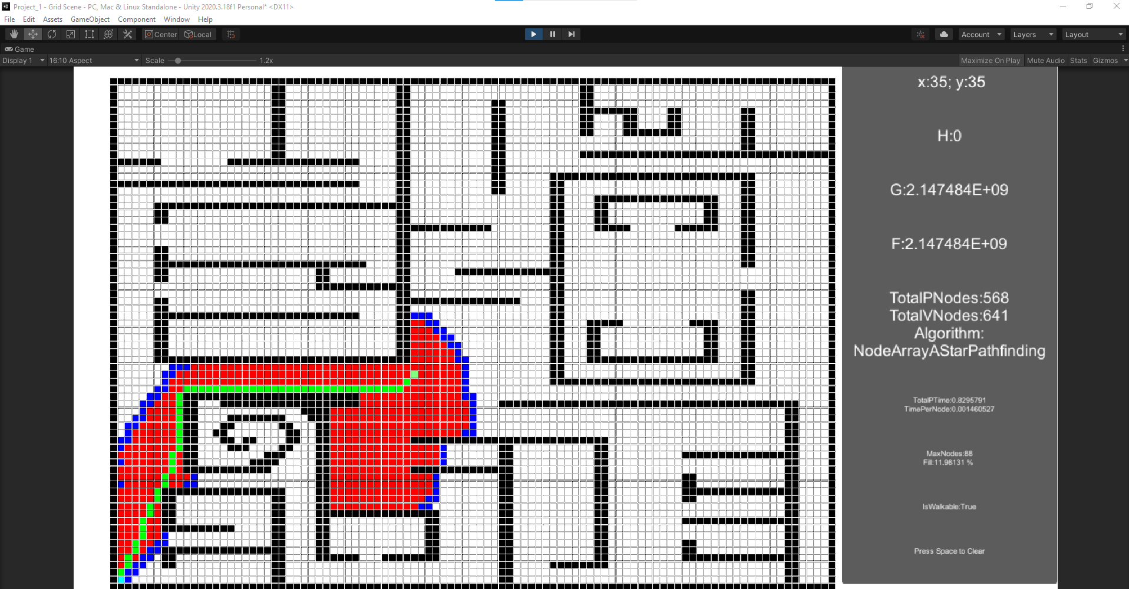

Figure - Test case 2 for Node Array A*

Figure - Test case 2 for Goal Bound

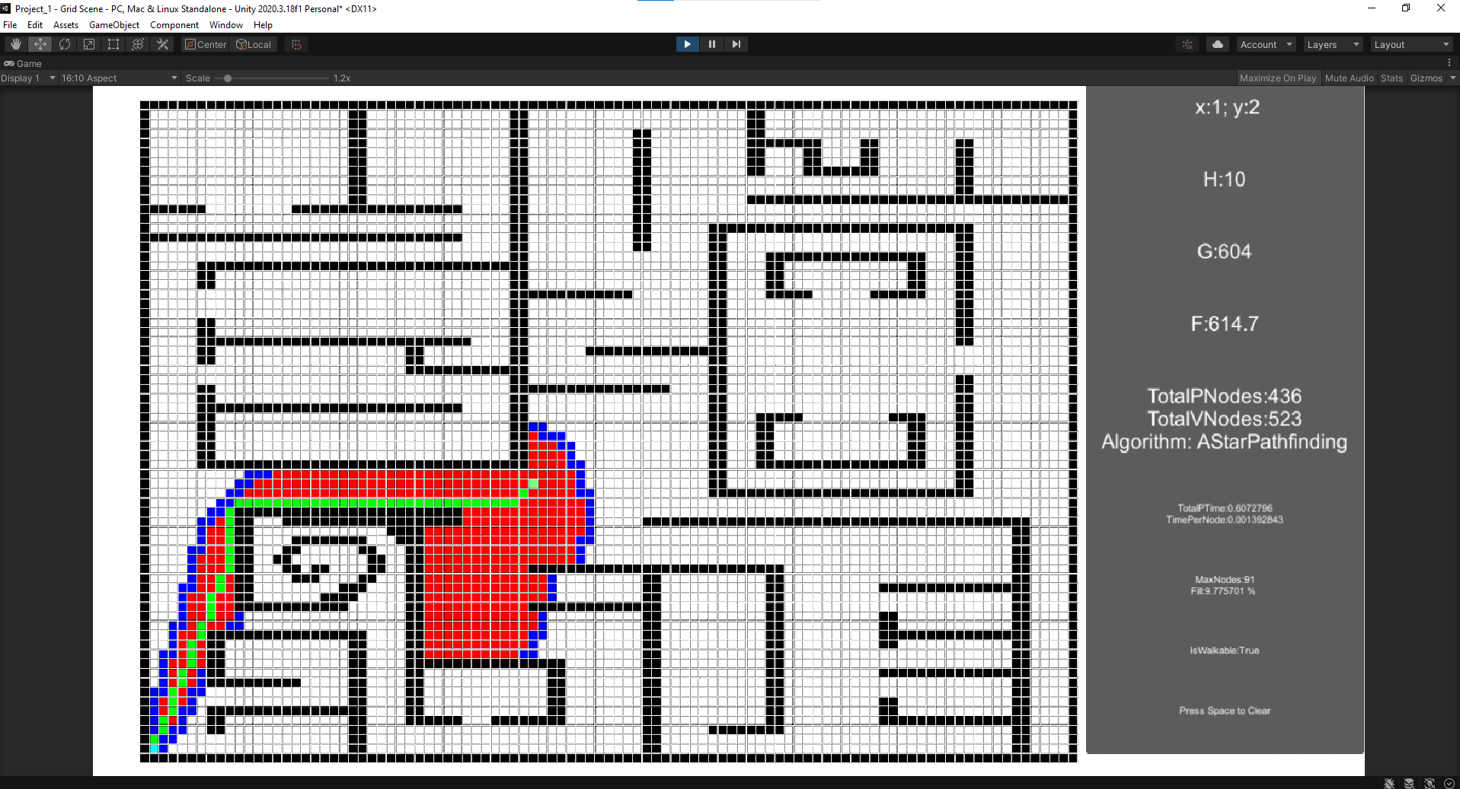

Figure - Test case 2 for A* with tie breaker

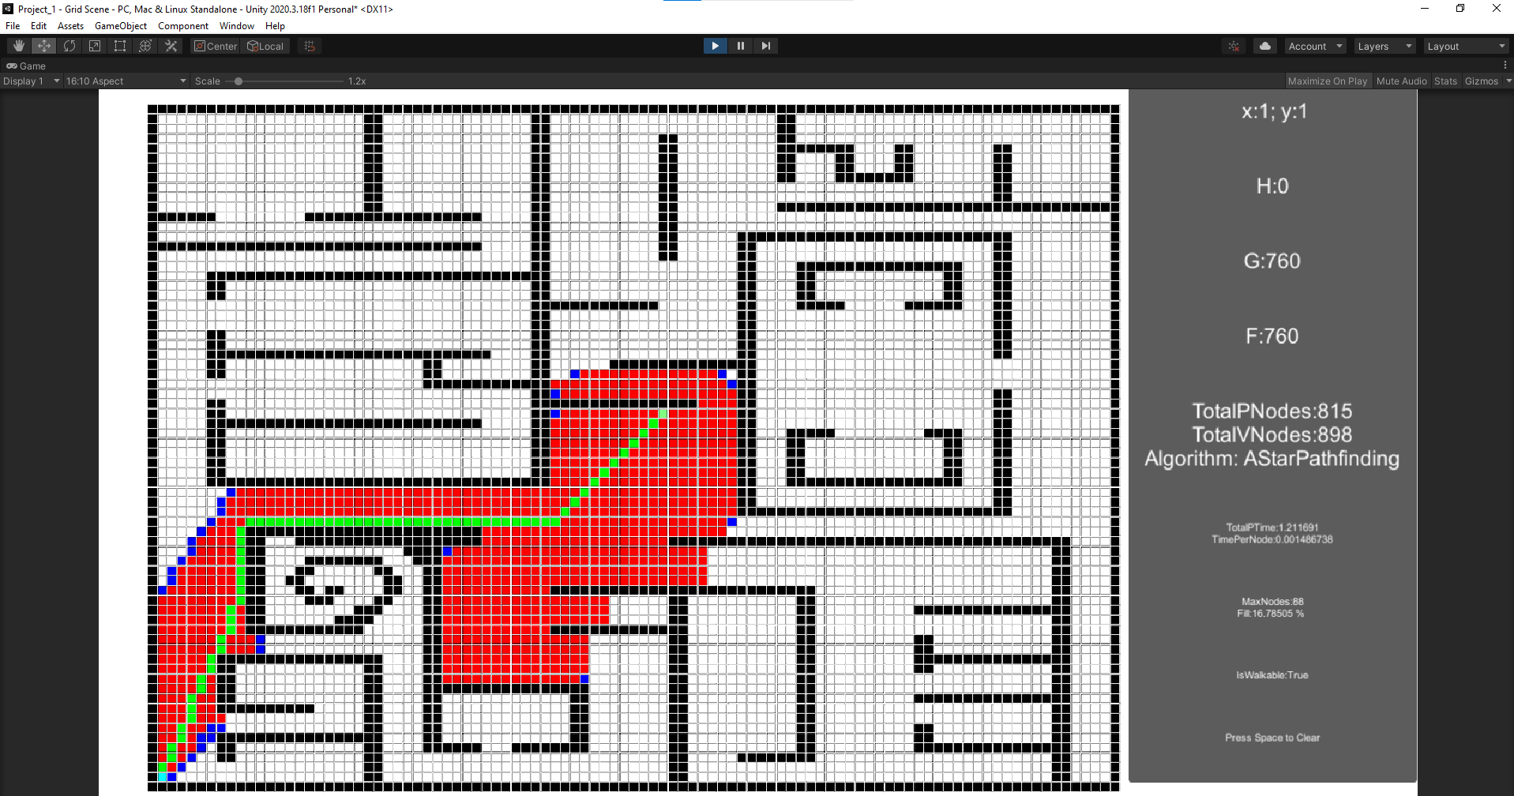

Figure - Test case 3 for A*, no tie breaker

Figure - Test case 3 for Node Array A*

Figure - Test case 3 for Goal Bound

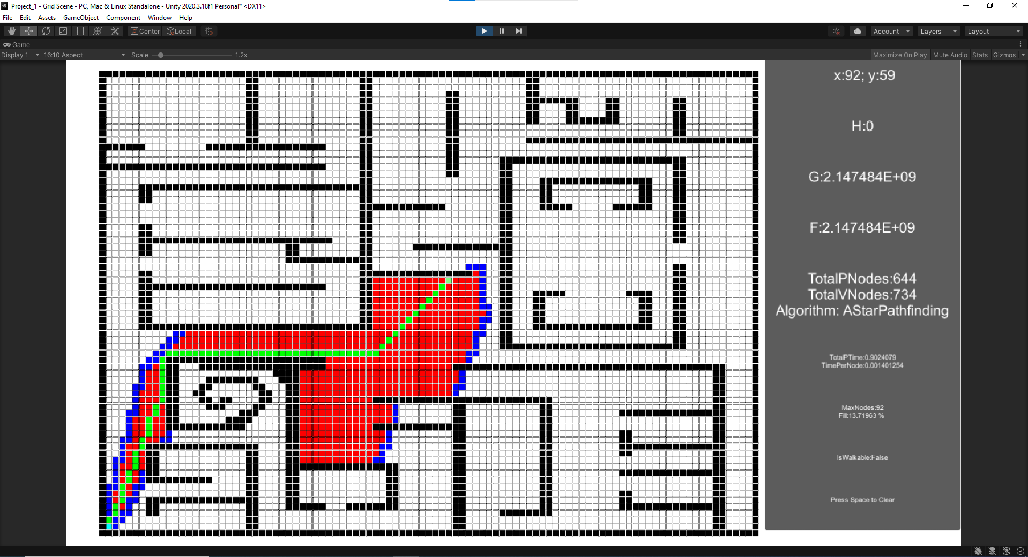

Figure - Test case 3 for A* with tie breaker

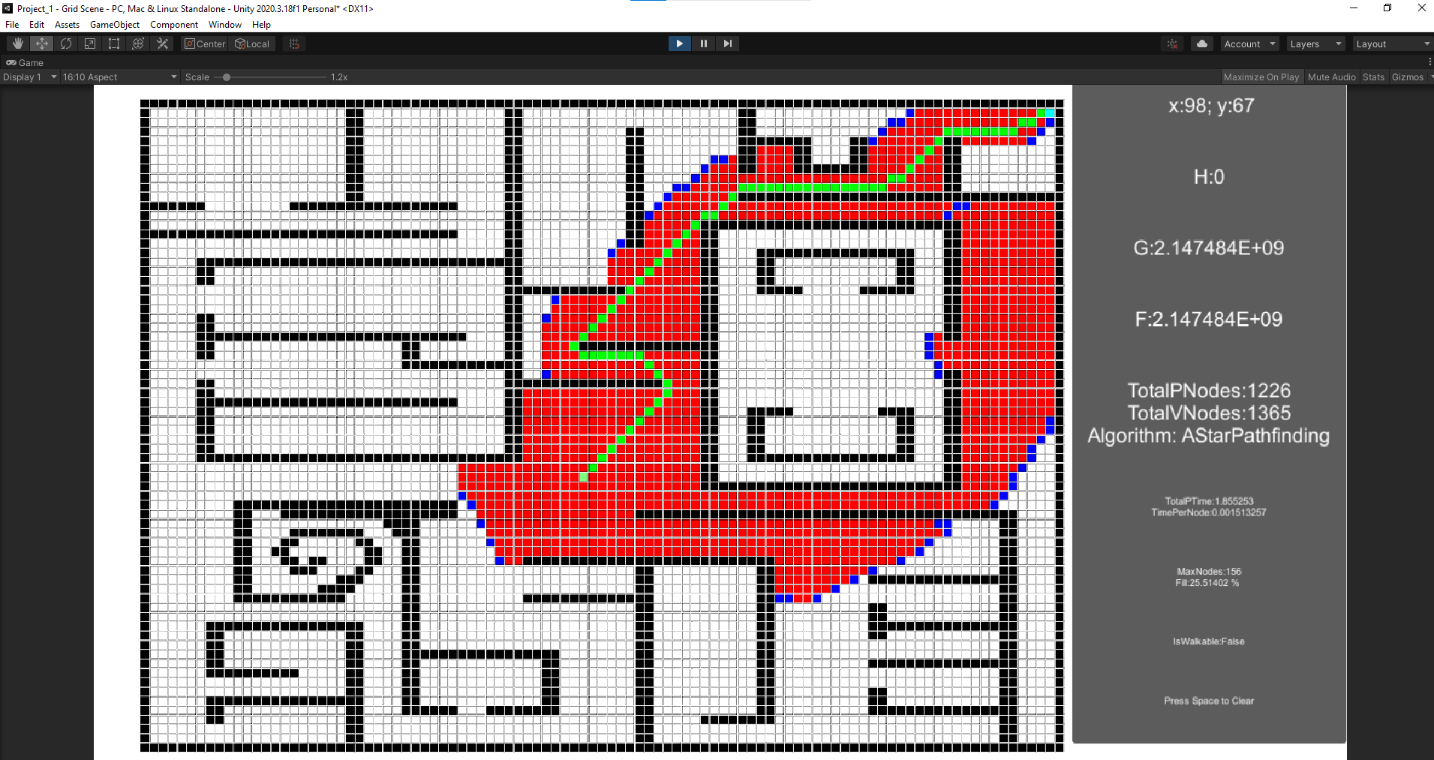

Figure - Test case 4 for A*, no tie breaker

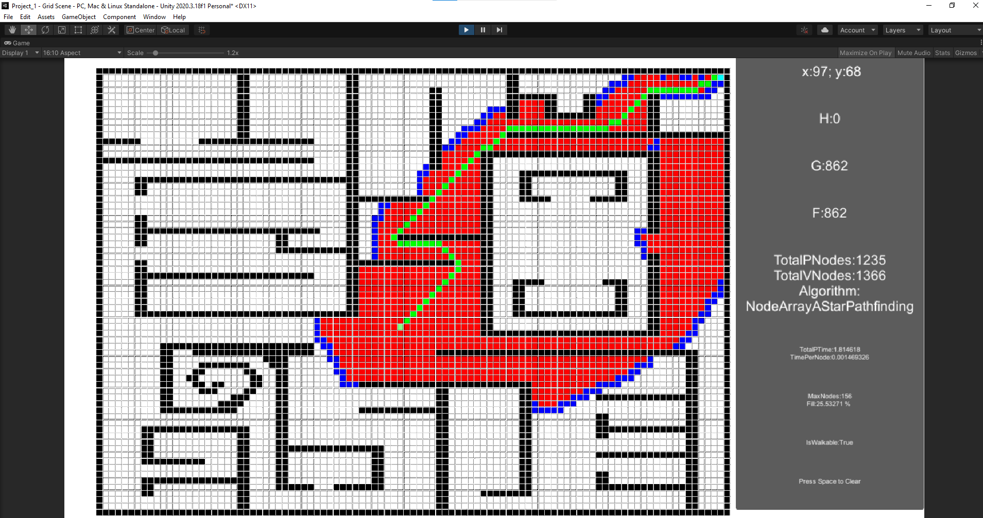

Figure - Test case 4 for Node Array A*

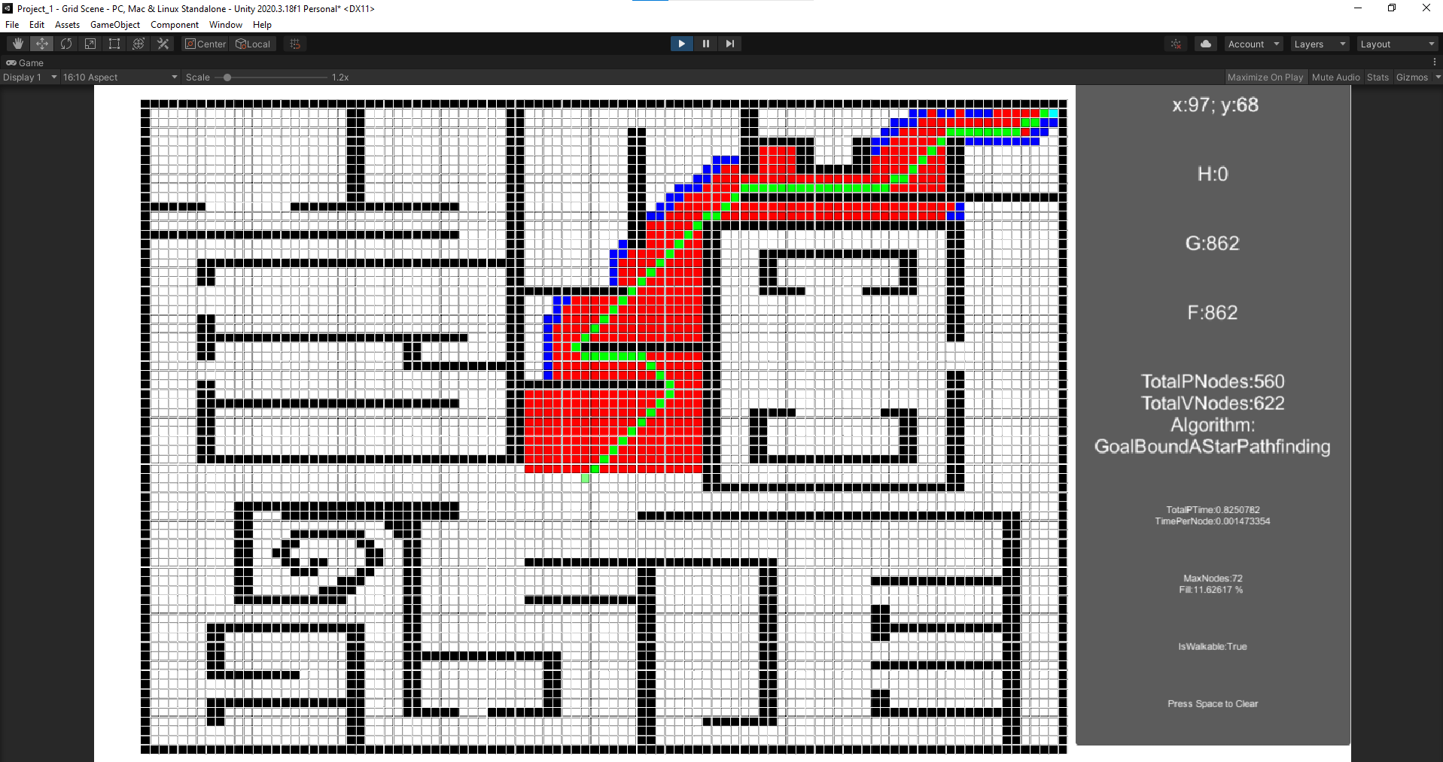

Figure - Test case 4 for Goal Bound

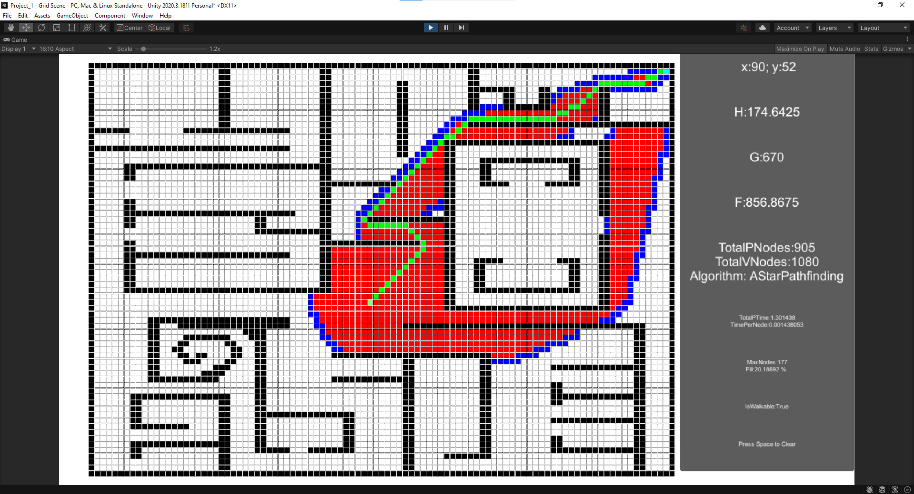

Figure - Test case 4 for A* with tie breaker

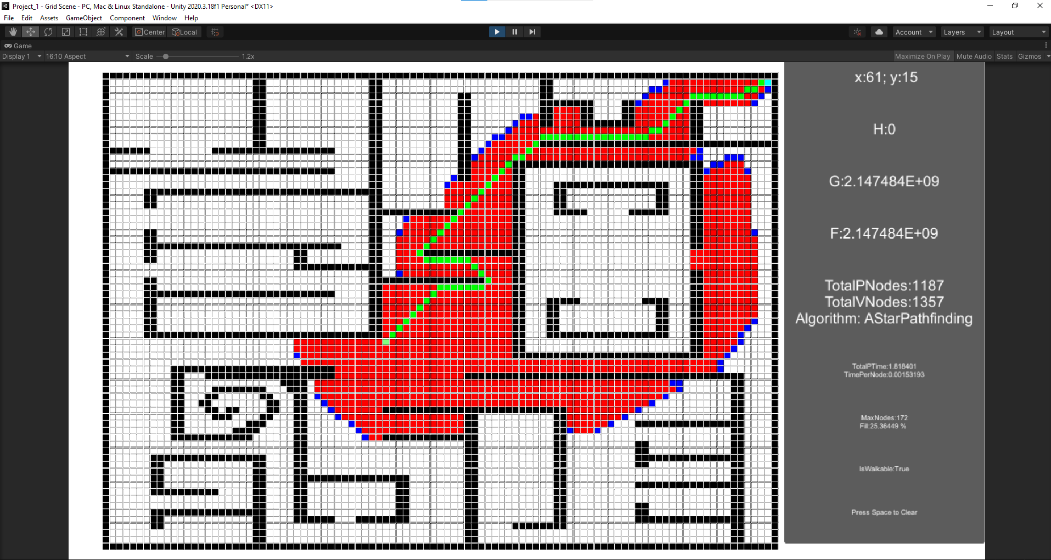

Figure - Test case 5 for A*, no tie breaker

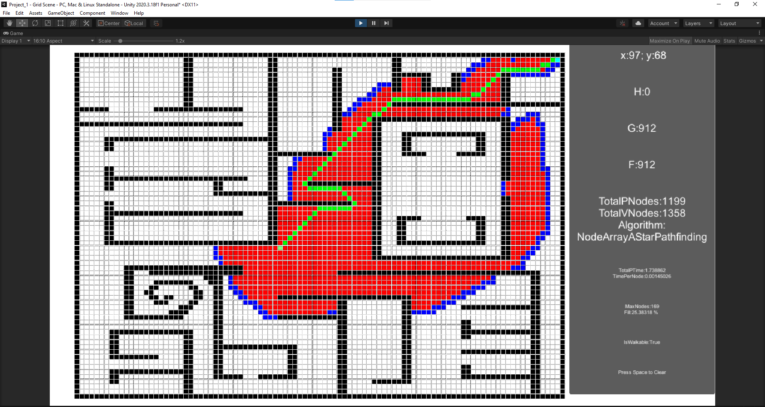

Figure - Test case 5 for Node Array A*

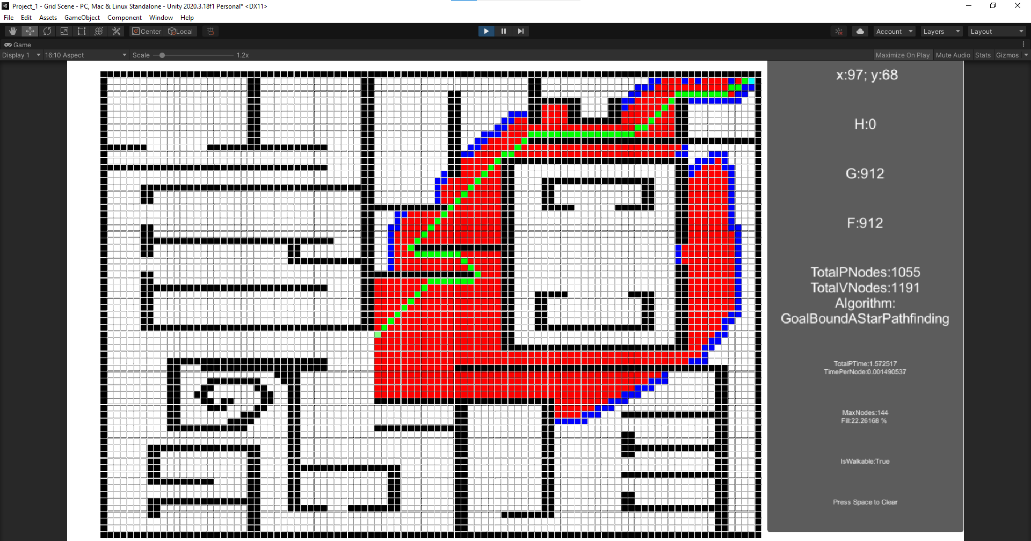

Figure - Test case 5 for Goal Bound

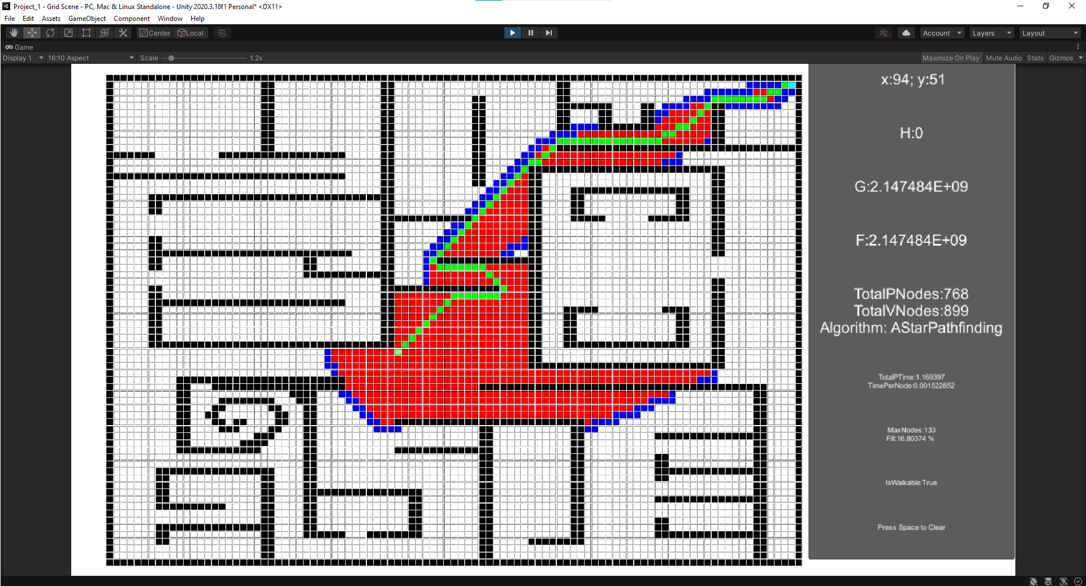

Figure - Test case 5 for A* with tie breaker

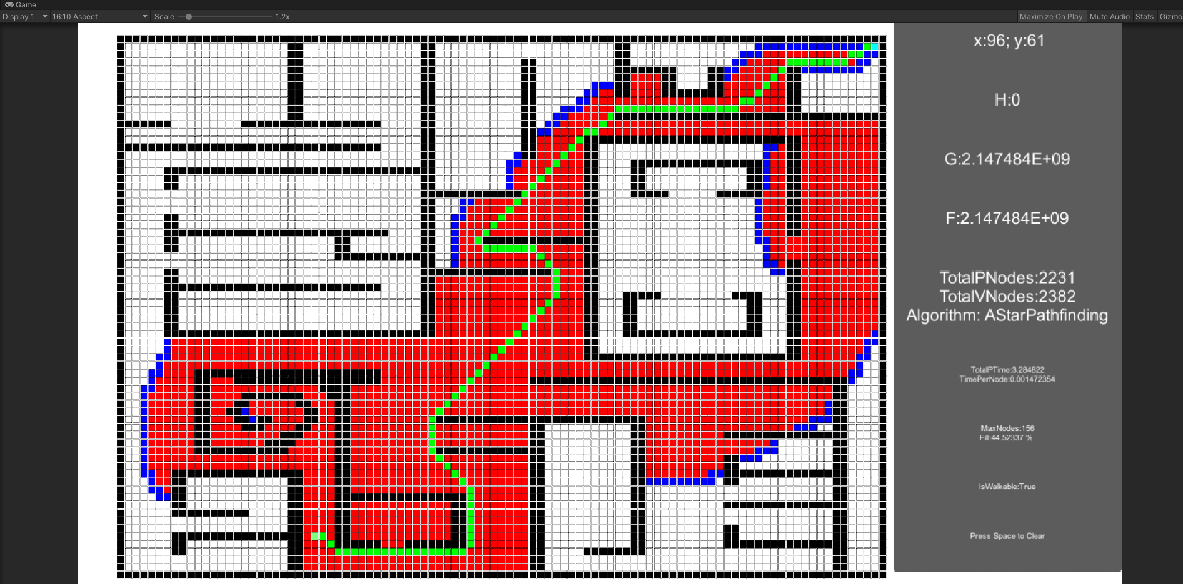

Figure - Test case 6 for A*, no tie breaker

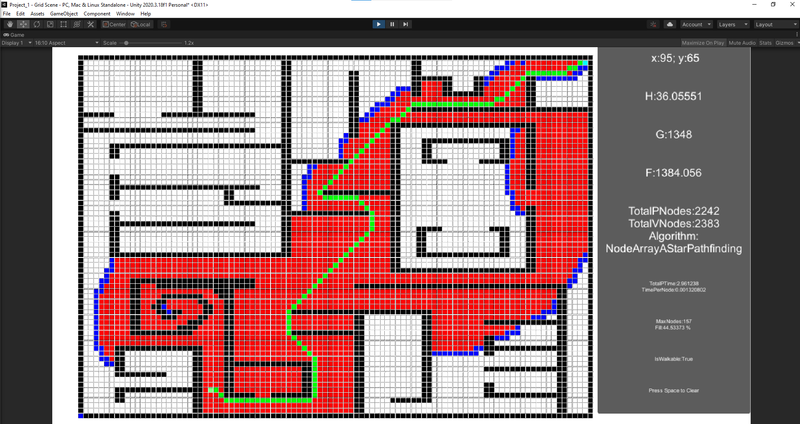

Figure - Test case 6 for Node Array A*

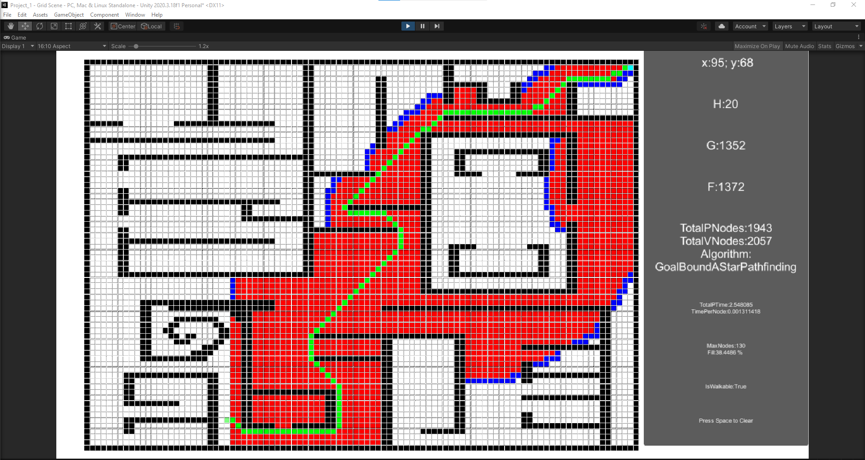

Figure - Test case 6 for Goal Bound

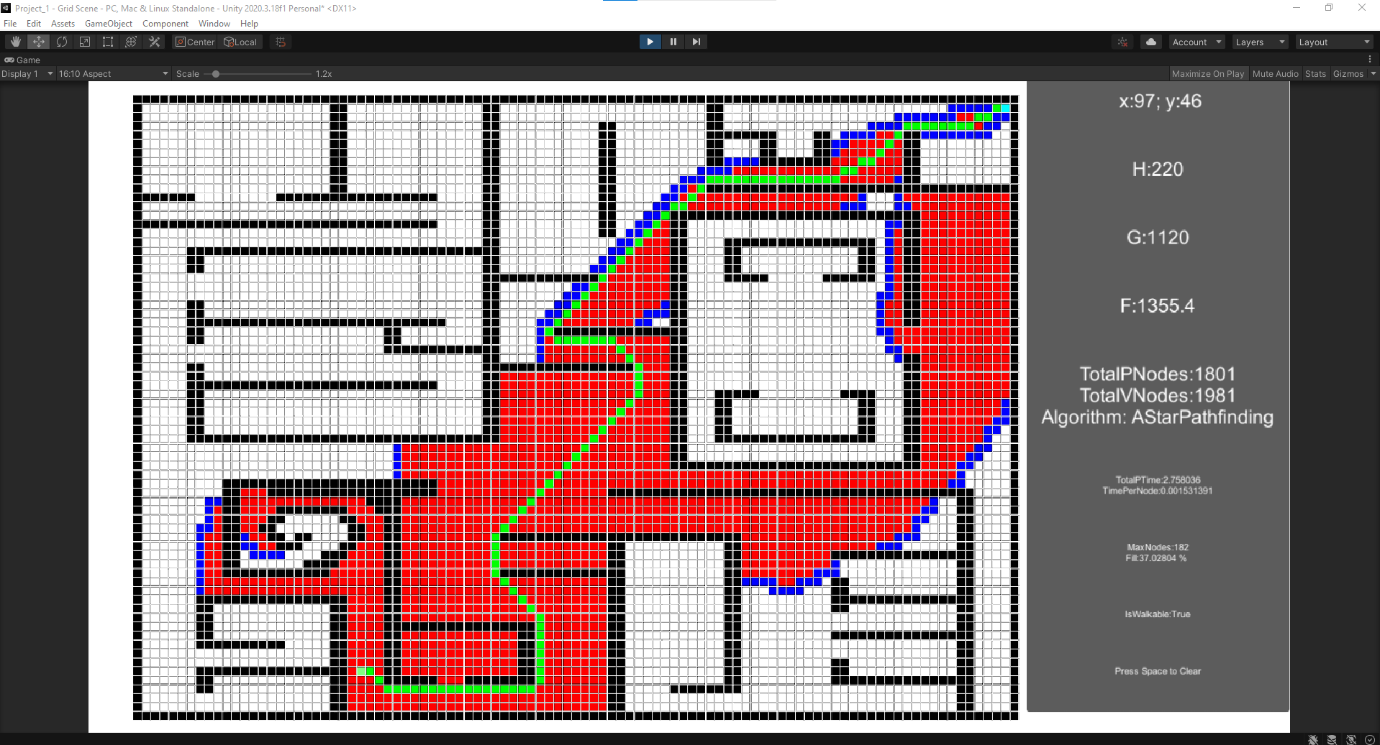

Figure - Test case 6 for A* with tie breaker